Experiment n°7

Head losses for laminar and turbulent flow

# Objective

The aim of this experiment is to highlight the differences between singular head losses in a laminar and in turbulent flow. The evolution of the K coefficient will be studied here.

# Theories

A singularity in a hydraulic circuit create a singular head losses, singular head losses are ruled by the following formula:

For singular head losses (minor losses): $∆Ps=K*\frac{1}{2}ρUm²$ K singular head losses coefficient.

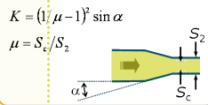The venturi tube can be seen as a convergent pipe followed by a divergent pipe.

Figure 1: Convergent pipe

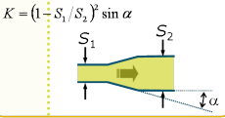

Figure 2 : Divergent pipe

For the orifice plate, pressures losses follow this law:

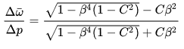

This formula can be approximate by



# Description of the installation

The HD98B Hydraulic Bench is used here. Pipe n°5 is mounted with a globe valve (blue) and a globe valve (yellow lever)

Pipe n°6 is mounted with a T like structure and a gate valve (yellow).

Pipe n°2 is equipped with a venturi tube, pipe n°3 is also equipped with a flow meter, it is an orifice plate flowmeter.

A rotameter is equipped on the circuit.

# Experiment

1. Check the opening of the exit valve;
2. Open the desired pipe;
3. Connect the manometers to the used pipes
4. Activate the pump;
5. Pick up values of the manometers in the following table
6. Establish a law for the singularity in the circuit.

|  |  |  |  |  |
| --- | --- | --- | --- | --- |
| Qv m3/s | U m/s | K | K theoretical | Measure differences (%) |

# Sources

Figure 1 and 2: http://res-nlp.univ-lemans.fr/NLP_C_M02_G02/co/Contenu_32.html